A REPORT ON

GAMERZ WEB APPLICATION

Submitted By

T. Nandakishore 20N31A12F0

Kethavath Sai 21N35A1213

Rahul Kumar 20N31A12D0

Faculty Incharge

B.Ramya Sri

APPLICATION DEVELOPMENT-I



Department of Information Technology

Malla Reddy College of Engineering & Technology

(Autonomous Institution- UGC, Govt. of India)

(Affiliated to JNTUH, Hyderabad, Approved by AICTE, NBA &NAAC with ‘A’ Grade) Maisammaguda, Kompally, Dhulapally, Secunderabad – 500100

website: www.mrcet.ac.in

2020-2024

TABLE OF CONTENTS

S.NO TITLE PG.NO

1. INTRODUCTION 01

1. APPLICATION DESCRIPTION 03

1. RESULT 14

1. CONCLUSION/FUTURE ENHANCEMENTS 15
2. REFERENCES 16

INTRODUCTION

OBJECTIVES

In the fastest-growing field of software engineering and development, one of the fastest-growing sectors is the gaming industry. As the technology in the gaming field advances, the number of players is also increasing day by day. Nowadays, we can see that everyone, from children to the elderly, is playing games.

A gaming website is by far the most effective way to present your game to your target audience. You might be able to reach more people by blasting social media ads. But once your audience shows interest in your game, they’ll want to learn more about it through your website.

The gaming sector is taking leaps with advancements in technology. With artificial intelligence, augmented reality, and mobile technology, games are getting some major upgrades. The extensive range of games entering the market is attracting a diverse demographic.

Companies are racing to tap into new customers and communities. It is crucial that they are equipped with a content marketing strategy that raises their brand’s visibility.

In order to develop a web-based game, we analyzed various available games and picked a strategy game as our choice. Various strategy games are available on the internet; among them, one is a business strategy game, so we chose to develop an Indian theme-based business strategy game commonly known as "monopoly." At the end of this project, we aim to achieve the following objectives:

• To develop the user interface of the game.

• To integrate user interaction in it.

• To develop and manage the back end of the game.

• To integrate game with social networking websites

## PURPOSE

The purpose of this website is to provide all kinds of games with the latest updates. Our website interface will be very easy to understand and easy to use because it is developed from the user’s point of view. On our website, players can access and play the different games, and we include the new games.

A gaming website is a great medium to promote a video game, create an online space that unites gamers, or share industry news. Gaming [website UI design](https://passionates.com/ultimate-website-ui-ux-design-guide/) is one of the key factors determining the user’s experience.

Gaming websites can do a lot more than just promote games. They are an excellent portal for connecting to other players and building an active community around your favourite game.

## AIM

Our main goal is to create a free gaming website and platform called "Gamerz" that is open to everyone and does not allow any third-party access to steal our data or infect our system with a virus.

The application aims to develop an easy-to-use and an open-source web application where users can access and play multiple games. This application consists of many games, from small ones like "Tic Tac Toe" to "GTA."

The main aim of the application is to provide a platform where users or players can access and play various types of games on one website. The website offers user-generated reviews of the games, allowing players to learn about the gaming experience of the desired game.

APPLICATION DESCRIPTION

A game is a structured form of play, usually undertaken for entertainment and relaxation. Games are sometimes played purely for enjoyment. On this website, we provide a description of every game, which tells about the storyline of the game. The games that are presented on our website are free of malware and viruses. The website will contain some simple modules that will help you easily use the website, and these modules provide different information about the website.

The players can download and install multiplayer games, solo player games, offline games, and online games. Our website can be understandable, interesting, easy to use, and effective. A good online game is one that keeps users interested for an extended period of time without becoming boring. According to a web article, the following are the features of a good online game:

* Player support and community
* A compelling and original concept
* Great graphics and environmental diversity
* Good customer service
* Fun gameplay
* Add-on and mod support
* Built-in player-game matching service
* Content additions and refinements
* Ease of player interaction
* Accessibility
* Developer support of player feedback
* Control of cheating
* Challenge

A good game should pose a challenge to the users to think or react spontaneously. People like to solve challenging problems and are engaged in such activities for a long time. By accomplishing the task, user feel a sense of success.

• Feel

The overall look and feel of the game should fascinate the users. Look of the game should be interesting and not boring. The feel of the game includes graphics, presentation of the game.

HISTORY OF GAMING

In October 1958, physicist William Higinbotham created what is thought to be the first video game. It was a very simple tennis game, similar to the classic 1970s video game Pong, and it was quite a hit at a Brookhaven National Laboratory open house.

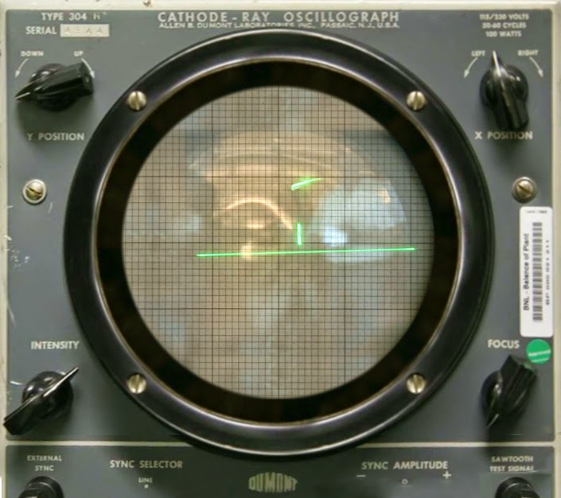

The game's generation spans seven generations;

* The second generation begins in 1977 and ends in 1983.
* The third generation begins in 1985 and ends in 1989.
* The fourth generation begins in 1989 and ends in 1996.
* The fifth generation begins in 1993 and ends in 2002.
* The sixth generation begins in 1998 and ends in 2006.
* The seventh generation started in 2004 and is still in use.

The generation of our time is the seventh generation; this era started in 2004 with the releases of consoles such as the Nintendo Wii, the Sony Playstation-3, and the Microsoft Xbox 360.

GAMING INDUSTRY

Games are commonly termed massively multiplayer online role-playing games (MMORPGs), which are usually shortened to MMOs. The video game industry has grown from niche to mainstream. As of July 2018, [video games](https://en.wikipedia.org/wiki/Video_game) generated US$134.9 billion annually in global sales. The industry has influenced the advance of [personal computers](https://en.wikipedia.org/wiki/Personal_computer) with [sound cards](https://en.wikipedia.org/wiki/Sound_card), [graphics cards](https://en.wikipedia.org/wiki/Graphics_card), [3D graphic accelerators](https://en.wikipedia.org/wiki/3D_graphic_accelerator), [CPUs](https://en.wikipedia.org/wiki/CPU), and co-processors like [PhysX](https://en.wikipedia.org/wiki/PhysX).

Vendors generate revenue from such gaming environments through regular financial subscriptions made by players and/or from the value of virtual world artefacts. Fundamental to measuring the financial success of such games is the number of players actively participating. The more players there are, the higher the financial rewards for a vendor. **More than 3.2 billion people worldwide play games**. The console gaming market is expected to grow to $72.67 billion in 2022. At the end of 2021, approximately three billion players will have spent a combined $175.8 billion on games. While new or returning players made up 20% of the gaming market in 2020, veteran players who were already playing prior to 2020 made up the other 80%! It is expected that by the end of 2024, it will generate revenues of $218.7 billion.

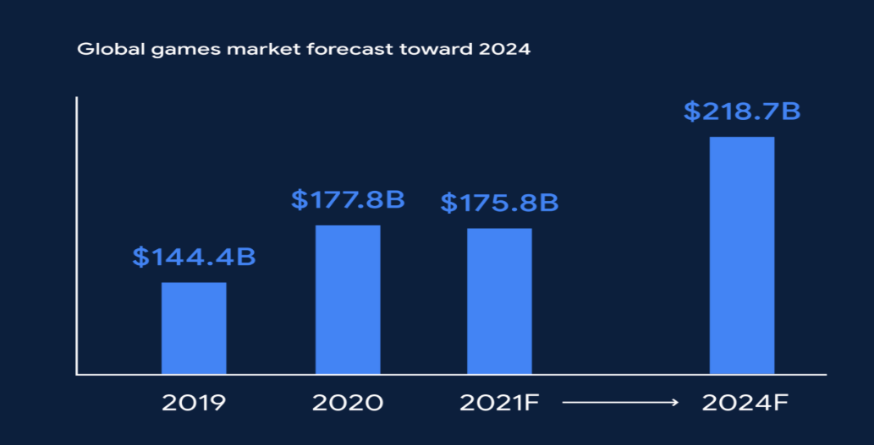

OUR WEBSITE INCLUDES

Our website is free to accessible and doesn’t contain any advertisements or popups. Our website doesn’t contain any third party access so that customer or user data is completely safe.

If a customer or user downloads or buys a game, the user is directed to the official page of the game.

* By this the user downloads the right game without downloading the unwanted resources.
* And no other viruses are installed in the system through the application where the user feels completely safe.

Our web platform consists of various types of games which includes small games like tic-tac-toe to large video games.

MODULES IN OUR WEBSITE

1. Header section
2. Games
3. News
4. Promotion section
5. Reviews
6. Videos
7. Contact us
8. Footer section

HEADER SECTION

A header is a term given to a main strip or icon that sits towards the top of our website. Its purpose is to introduce our branding and send out a message. Headers usually appear on every single page of your website, though they can vary in placement if required.

Our header section includes our brand name and following elements:

* Home
* Games
* News
* Reviews
* Videos
* Contact-Us

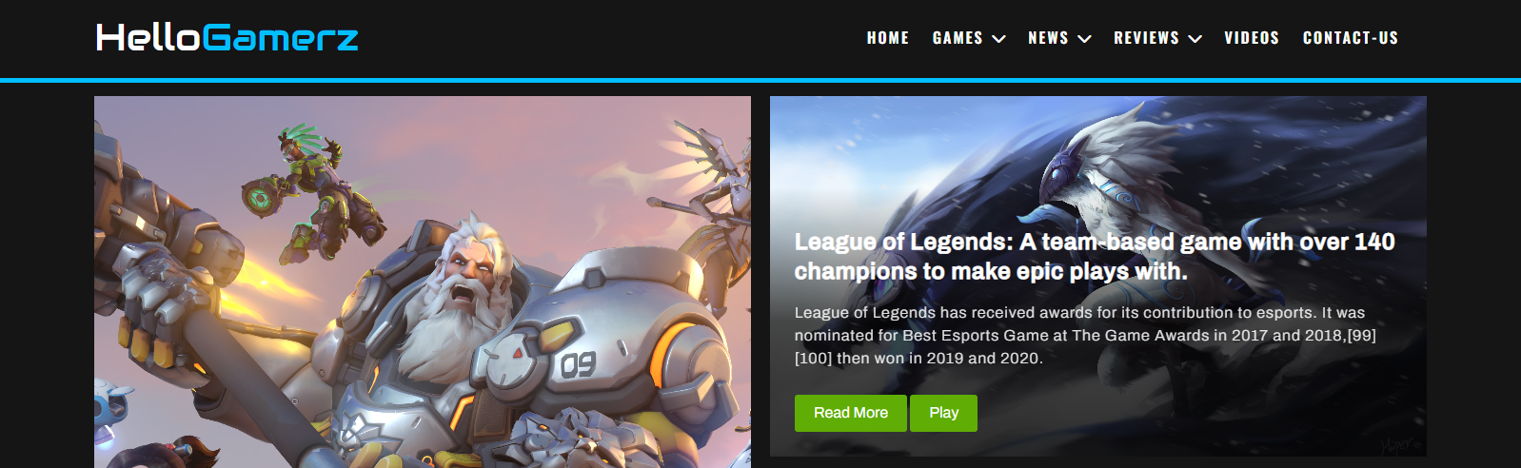

GAMES

This element directs you to the games section, which contains various types of games. Some of the games are directed to their official website, where you can download and buy the game, which is set by their official gaming organization. By doing this, you are directly directed to their official site, which saves you time and prevents you from downloading unwanted resources along with the game, which may include viruses that affect your system and steal your data.

We included everything from small games to large videogames, as well as 3D games.We also provided some free games where users did not need to install the games and could directly play them through our website.

These games include action, adventure, puzzle, board, racing, shooting, and so on.

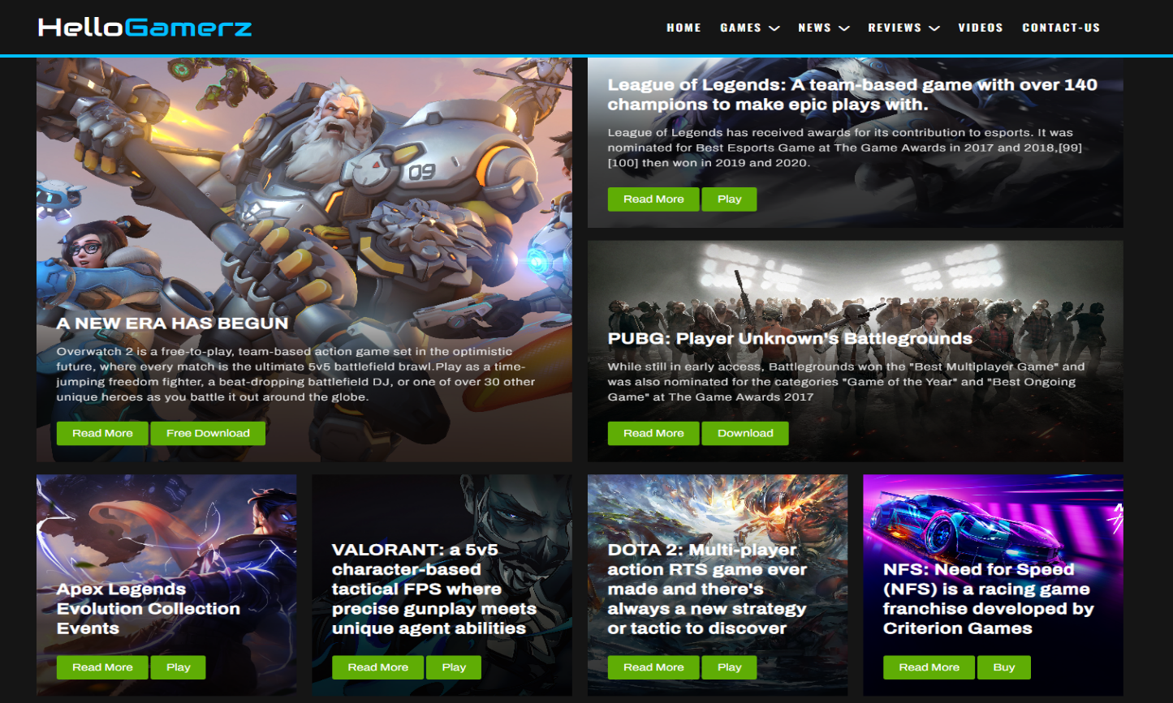

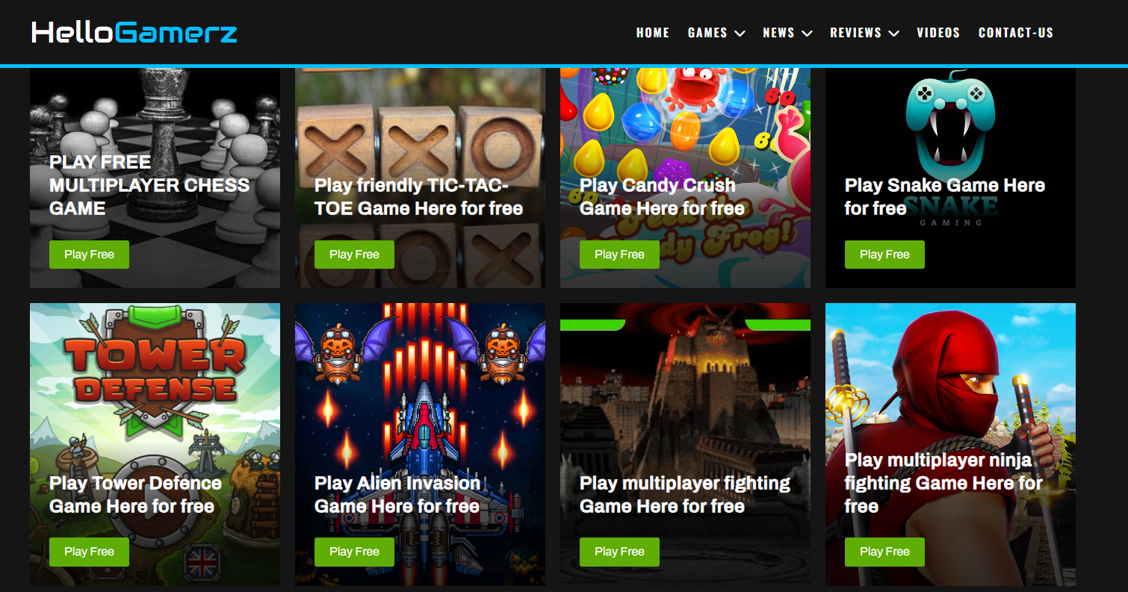

NEWS

This element directs you to the news section which contains the latest and trending news about the games. This section provides you the news of latest released games, game updates, their reviews from the global users and so on.

This keeps the user to know more about the games and keep himself updated. In this module, the player receives information about tournaments and game events, allowing them to keep track of their participations and competitions.

.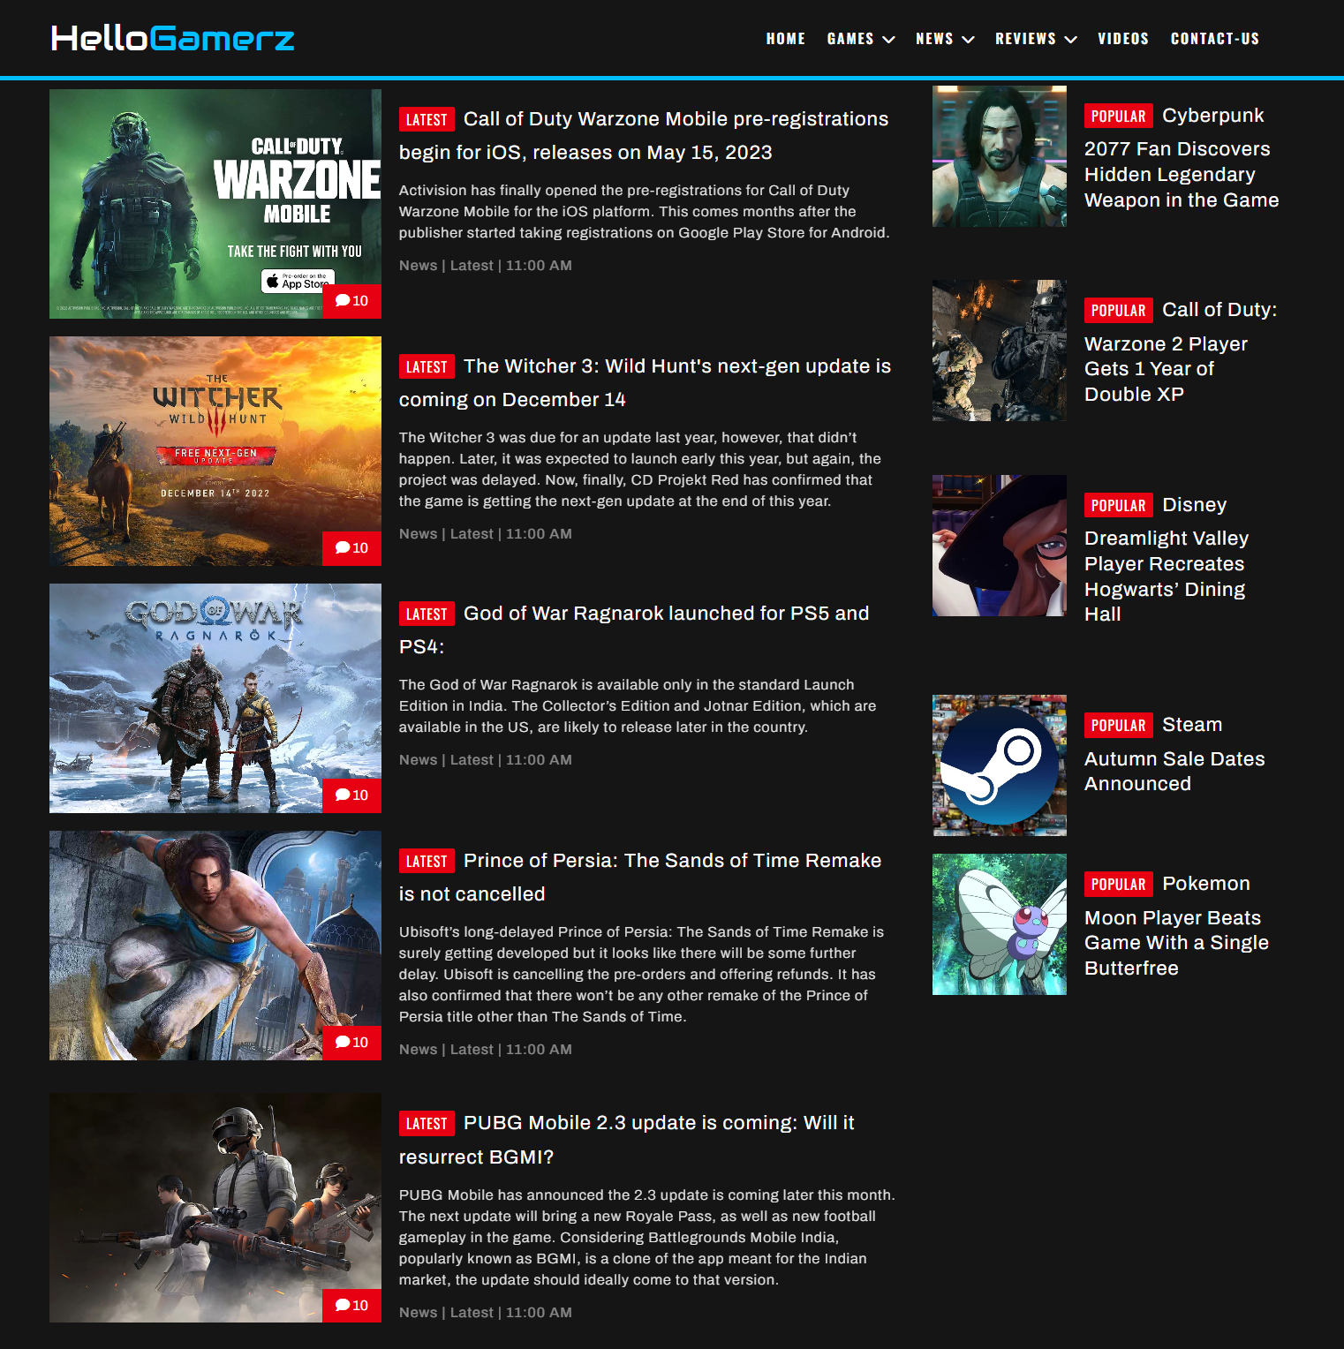

PROMOTION SECTION

In this section, we promote or display a new game that has recently been released and is currently trending. This section is usually for advertising purposes. Here, users can learn about the latest and trending game.

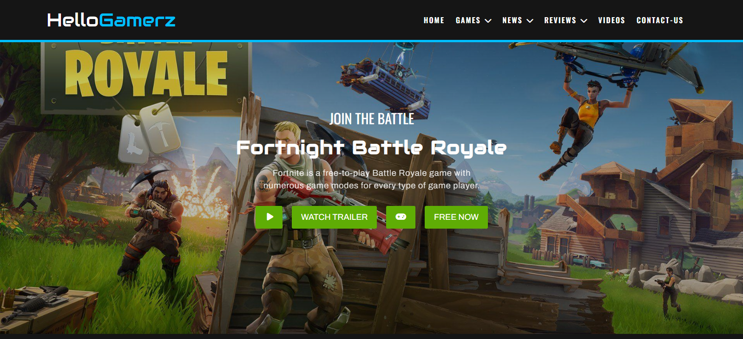

REVIEWS

This element directs you to the reviews section which contains the user or player reviews of a particular game. In this section, the user gets to know the user-based reviews of games. The users can also give reviews based on their gaming experiences. Users can learn about the game's features, such as its graphics, story, controls, and more, in the review section. The players can give their feedback to the games, so the developers can get to know about them and modify them to meet gamers' requirements.

As a result, the new player or user can get a thorough understanding of the game before purchasing or playing it.

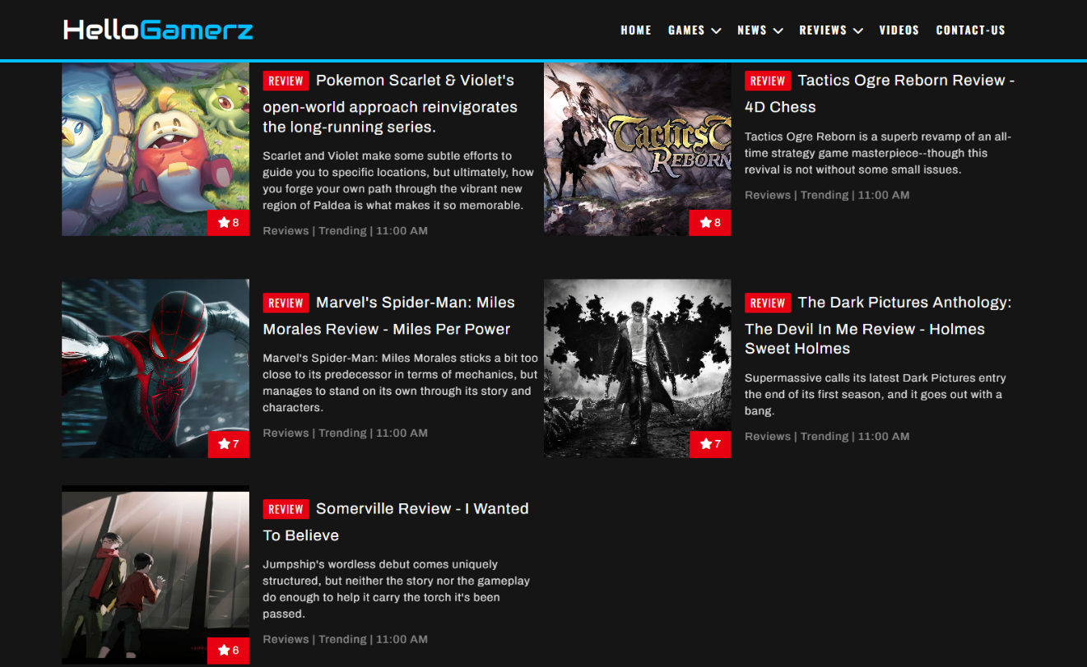

VIDEOS

This element directs you to the Videos section, which contains the trailers of newly released games, and you can also learn how to play that particular game.

If the user doesn't know how to play his desired game or clear a particular level, he can view it here and get a good understanding of playing or clearing a particular level of that game.

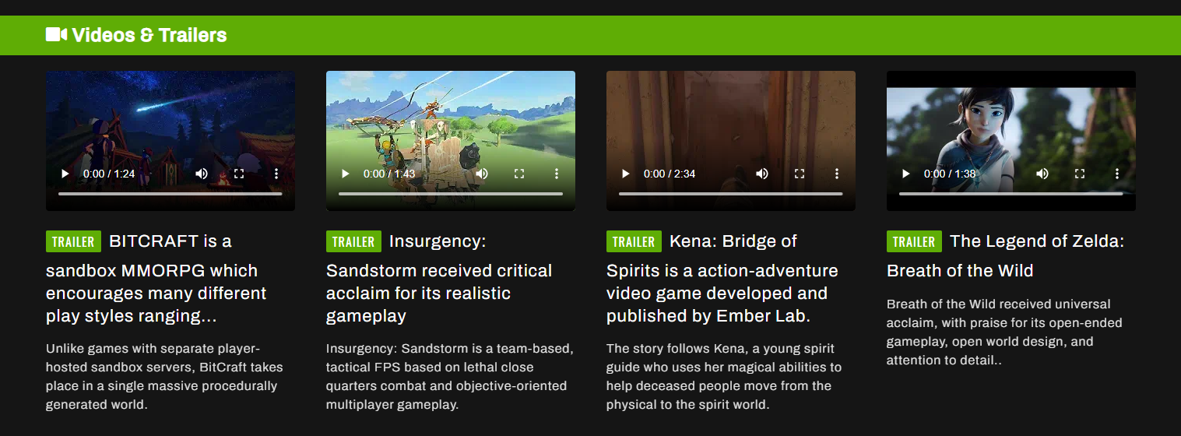

CONTACT-US

This element directs you to the contact page, where the user or player can contact us if they have any queries. If they have problems playing a game, find a problem on our website, or find any difficulty, they can contact us so that we can help them clear or solve their problem.

This helps us improve our website and make users happy.

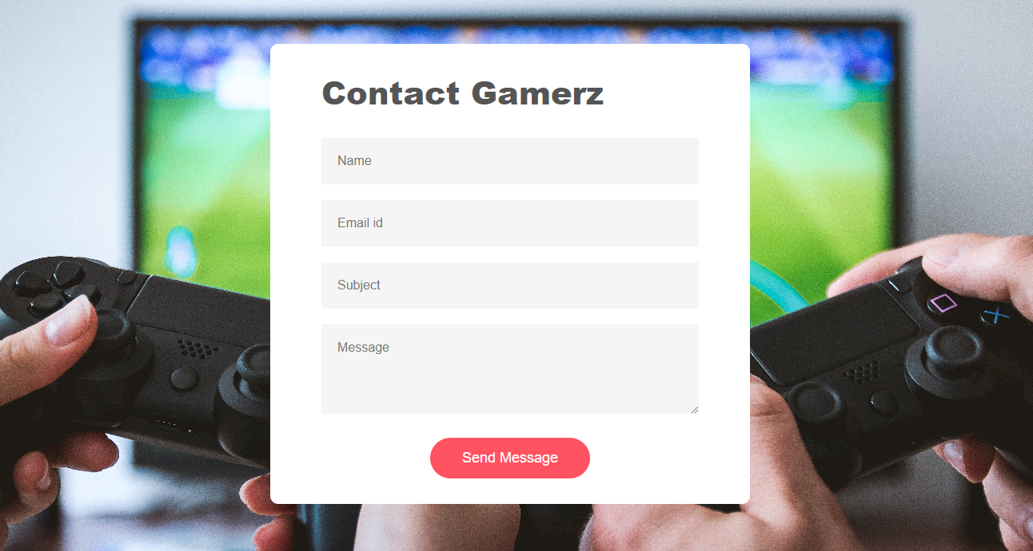

FOOTER SECTION

This is the bottom of our page. Here, users can connect with us on social media sites like Facebook, Twitter, Instagram, and YouTube and get more information and updates about our website and games.

This page contains the following subpages:

* About Gamerz
* Advertise
* Privacy and Policy
* Terms of use
* Contact
* Reviews



USER PERSPECTIVE

Our website is built with user’s point of view. We followed a principle while designing this application: "What you see is what you get".

Our website is effective and easy to use, so anyone can easily access or browse it. Our main motto is to target the audience.

Presently, there are lots of online gaming websites available, but multiplaying is not available for some of the websites. Some of these websites are less interactive to the user. There are lots of people who are stressed by the complexity of their jobs and find much pleasure and relaxation from these games. A chat system is also included for users to interact with other players. Here, users can make friends and play with each other.

* Users who play games are the primary target audience for the proposed system.
* Another important group of users of this system are those who play such games just for Fun

RESULT

The project has been completed successfully as specified by the requirements.

The implementation and testing have been done in a step-by-step manner.

Each module has been developed and tested individually to obtain the required output

in the desired form.

The website is successfully executed without any types of errors or problems. And the games which are developed by our team are successfully working as expected.

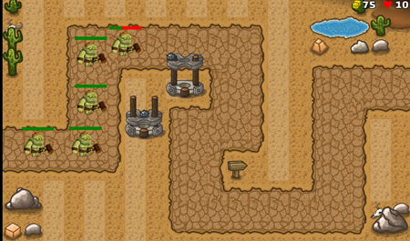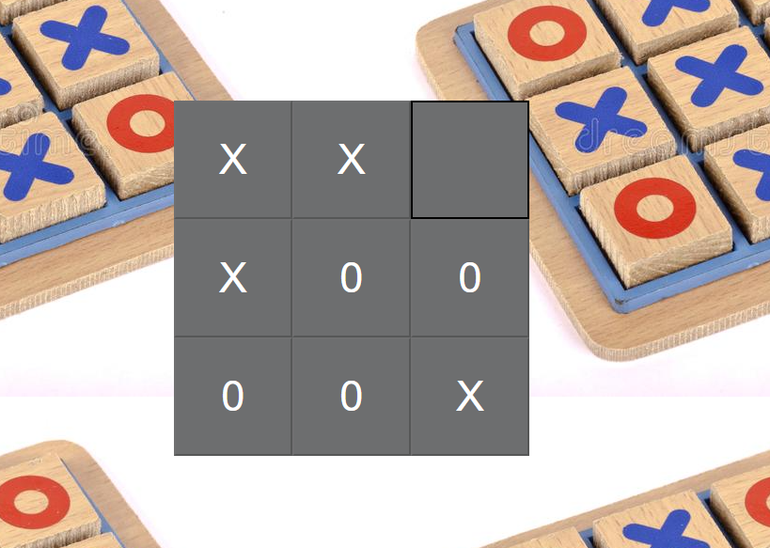

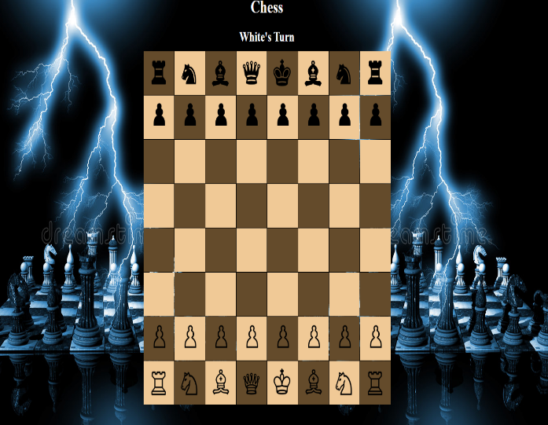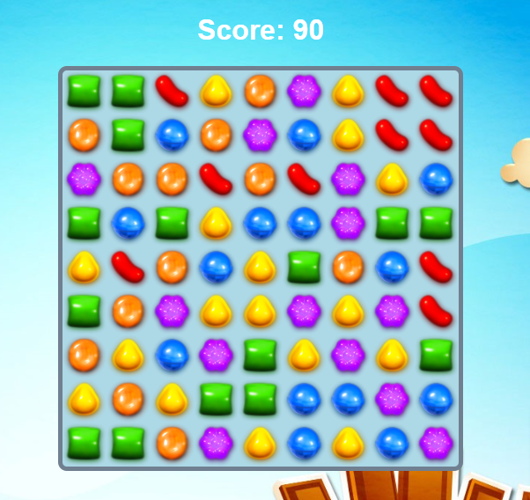

CONCLUSION / FUTURE ENHANCEMENTS

## CONCLUSION

On our way to working on this interesting project, we learned many things. We gained valuable experience on the stages involved in developing this web application that could be useful while working for a professional company while working on this project. During the duration of this project, we learned the following things through the implementation and testing of the project:

* Hypertext Markup Language
* Javascript

FUTURE ENHANCEMENTS

Future improvements can be made in certain areas of the project. The process model selected is the agile model. So that the new options can be implemented to a later version of the same design. The update of the application is an important feature of agile process model designs. The future enhancements of the proposed system that we have estimated are given below:

* Adding more games to the system and extending multiplayer options.
* Improving the chat system and including advanced methods for notification.
* There is always the possibility of enhancing UI/UX and responsive design.
* Providing a refund in case the player doesn't like the game within the allotted time.
* Enabling an alert feature if the user uses the website for more than one hour.
* Taking care that both players are on the same level when playing a multiplayer game.
* Abusing others in chat will be strictly banned. If any player reports the violation more than three times, he or she will be suspended for three days from playing that particular game.
* Enabling Identity registration so that minors can have limited access to the games.

# REFERENCES

BOOKS REFERRED

1. HTML & CSS: Design and Build Web Sites - Book by Jon Duckett.
2. Learning Web Design - Book by Jennifer Niederst Robbins.
3. Game Feel: A Game Designer's Guide to Virtual Sensation by Steve Swink.
4. Chris Crawford on Game Design by Chris Crawford.
5. A Theory of Fun for Game Design by Raph Koster.